**REST-Representation state Transfer**

CRUD-create, read, update, delete

**Standard http requests:**

Get, post, put, delete

Express: -

setting an environment variable using set on windows

set PORT=5000

1. sets the port globally,
2. using the default port or creating a port for running the server
3. const port =process.env.PORT || 3000;

app. listen(port,()=>console.log(`${port}`))

**ROUTE PARAMETERS: -**

GETTING SINGLE ID VALUE: -

app.get('/courses/:id',(req,res)=>{

res.send(req.params.id);

});

**GETTING MULTIPLE ID VALUES: -**

app.get('/courses/:year:month,(req,res)=>{

res.send(req.params)

}); //this gives the object with year and month

**HOW TO PASS A QUERRY STRING: -**

localhost:3001/2001/06?sortBy=name;//passing in browser URL

**getting the query**

app.get(''/courses/:year:month',(req,res=>{

res.send(req.query)

}))

Program:-

const express=require('express');

const app=express();

// describing routes

app.get('/',(req,res)=>{

res.send('hello World');

});

app.get('/courses/:id',(req,res)=>{

res.send(req.params.id);

})

const port =process.env.PORT || 3001

app.listen(port,()=>console.log(`listening at port ${port }`))

**CRUD Operation: -**

* **Get:**

app.get('/cources/:id',(req,res)=>{

const found=courses.find(d=>d.id===parseInt(req.params.id))

if(!found)res.status(404).send(console.log("course not found")) //here if response status===404 logging error

console.log(found) //if course found we are logging the result

})

* **POST:**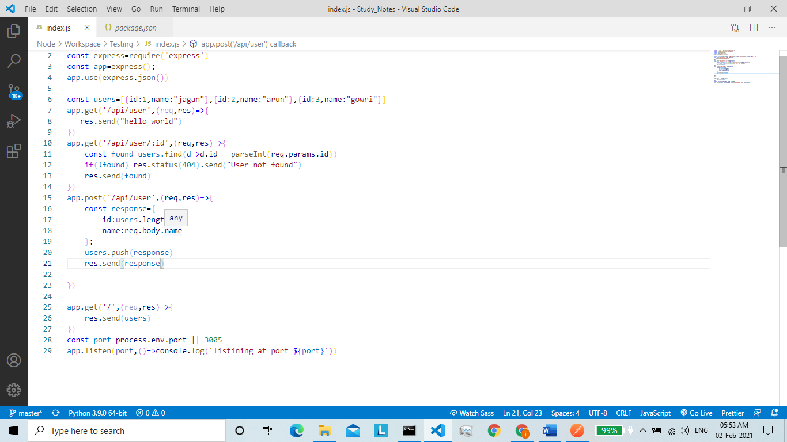
* app.use(express.json()) this line is very important for getting the json response and returning it.